
Rationalising the denominator

1 Evaluate each of the following. (The first one has been done for you.)
(a) 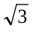 × = 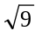 = 3 | (b) 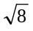 × = 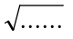 = ……
(c) 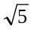 × = = …… | (d) 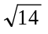 × = = ……
Surds in the denominator
When there is a fraction with a surd in the denominator, e.g. 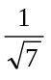 or 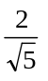, we change the denominator so it no longer contains a surd. This process is called rationalising the denominator.
2 Express each of the following with a rational denominator. (The first one has been done for you.)
[multiply top and bottom by the surd in the denominator.]
(a) 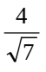 = × 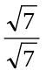  = 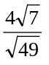  = 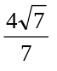 | (b) 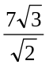 = × 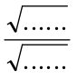  = 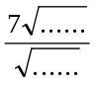  = 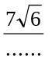
(c) 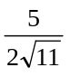 = ×  = 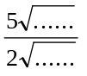  = 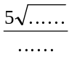 | (d) 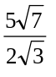 = ×  =  =
3 Express each of the following with a rational denominator.
(a) 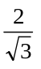 = ×  = 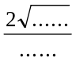 | (b) 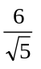 = ×  = 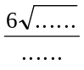 | (c) 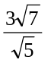 = ×  = 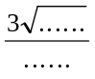
(d) 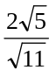 | (e) 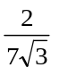 | (f) 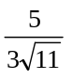

Rationalising the denominator
Answers

1 (b) 8 (c) 5 (d) 14
2 (a) 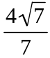 (b) 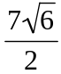 (c) 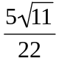 (d) 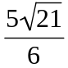
3 (a) 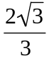 (b) 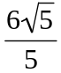 (c) 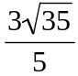 (d) 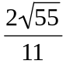 (e) 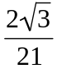 (f) 